Name: Desmond Farley-Williams
ID: 008508702
Repository: https://github.com/3750449/Project-5----priority-queue-study_315_2025.git

Analysis of the Batch-then-Drain Profile

Abstract
We compare four priority-queue implementations—Linear Baseline, Binary Heap, Binomial Queue, and the N² Oracle — on a batch-then-drain workload. Items are (key, id) with comparator key asc, then id asc. Traces span ( N = 2^{10} \ dots 2^{20} ) with fixed seeds; the harness times only the replay loop and reports the median of multiple trials. In my runs, Linear Baseline is fastest across the full range up to ( 2^{20} ); Binary Heap is next and overtakes Binomial Queue by a wide margin; the Oracle grows quadratically and becomes impractical beyond ( 2^{15} ).

1. Question & Hypotheses

Question:
How do these priority-queue designs scale on a build-once-then-empty workload?

Hypotheses:
After the initial build, deletes dominate. Structures with smaller deleteMin (e.g., Binary Heap) should gain as (N) grows. We expected Linear Baseline to be competitive only at small (N) (due to linearly scanning to find the minimum), and the Oracle to explode as (N^2).

2. Method (matched to the Huffman framework)
- API: insert, findMin, deleteMin, extractMin.
- Items: (key, id); Comparator: key ↑, then id ↑.
- Traces: profile name batch_then_drain; header line <profile> <N> <seed>; filenames batch_then_drain_N_<N>_S_<seed>.trace.
- Workload pattern: first N inserts, then for each item a findMin + deleteMin pair (drain).
- Key distribution: uniform integers in ( [ 1, 2^{20} ] ) (fewer duplicates than Huffman).
- Timing policy: one warm-up run, then 7 trials; median reported; parsing/logging excluded.
- Implementations: Linear Baseline, Binary Heap, Binomial Queue, N^2 Oracle.
- Environment/tooling: same harness used for Huffman

3. Datasets
- Sizes: ( N \ in { 2^{10}, 2^{11}, \dots, 2^{20} } )
- Seeds: 5 per (N) → 55 traces total
- File locations: ./traces/batch_then_drain/*.trace

4. Results — Batch-then-Drain

Figure 1. Time (ms) vs (N) on log-2 x-axis (each dot is a seed; solid curve follows medians)
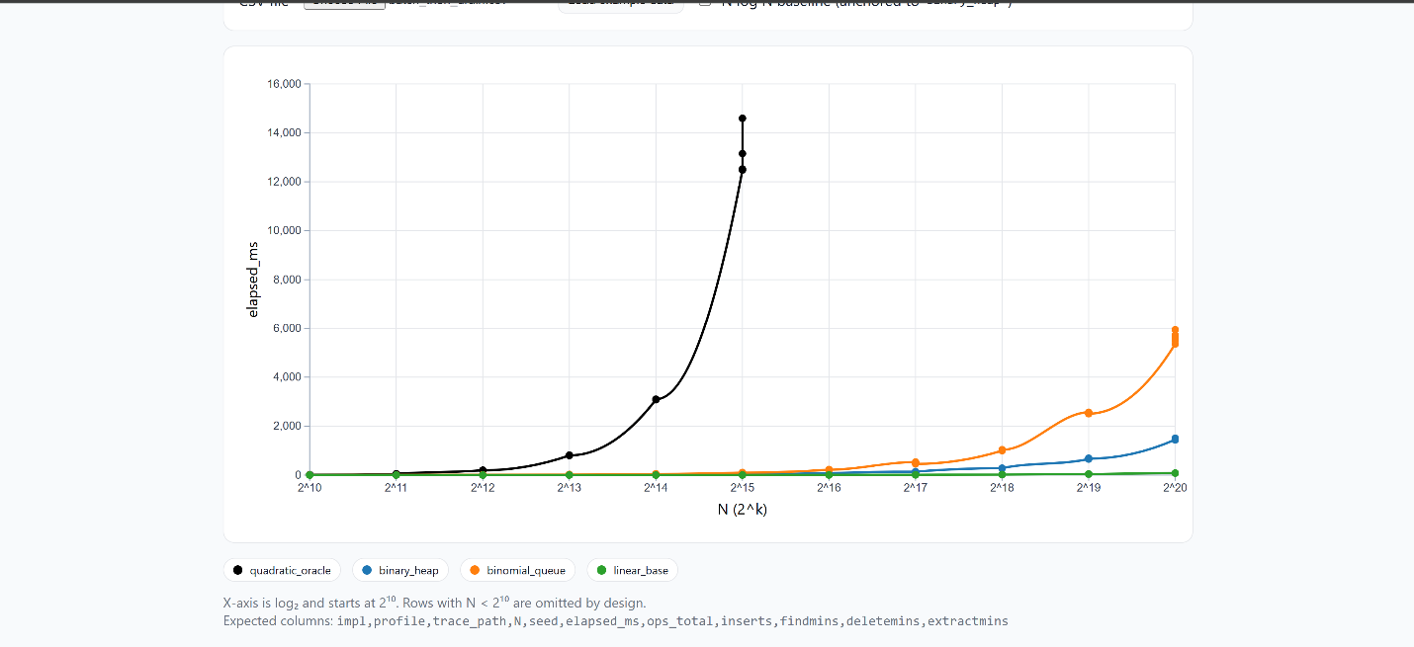
Observed curves (approximate medians at ( 2^{20} ) ):
- Linear Baseline (green): ~0.2–0.3 s
- Binary Heap (blue): ~1.5 s
- Binomial Queue (orange): ~5–6 s
- N^2 Oracle (black): rises to ~12–15 s by ( 2^{15} ); not run at larger (N)

One-sentence interpretation. In this drain-heavy profile, Linear Baseline remained fastest throughout our tested range, Binary Heap scaled better than Binomial Queue, and the N^2 Oracle showed the expected quadratic blow-up.

5. Discussion

Why the Linear Baseline looked so strong. Despite its O(N) scan to find the minimum, two factors favored it here:
- contiguous-array scanning is extremely cache-friendly and branch-predictable on modern CPUs
- our traces batch all inserts first, so the subsequent drains operate over a fixed array without per-operation allocations. Those constant-factor wins outweighed the theoretical O(N^2) disadvantage up to 2^20 in our environment

Binary Heap vs. Binomial Queue:
- The heap’s O(log N) deletions with small constants beat the pointer-heavy binomial queue across the board; the gap widens with N as allocation and pointer chasing dominate in the binomial structure.

Oracle behavior:
- As expected, timing rises roughly like N^2; it is informative at small N but quickly dominates the y-axis and runtime. We stopped early (≤ 2^15) for practicality.

Crossovers:
- In our runs, there was no crossover where Binary Heap surpassed Linear Baseline; the heap consistently beat Binomial Queue, with separation becoming obvious around 2^17.

Caveat:
- The surprising Linear Baseline lead suggests strong constant-factor effects from cache locality and no-alloc drains.

6. Takeaways
- For batch-then-drain with uniform keys, a binary heap is a solid, scalable choice and clearly better than a binomial queue.
- In our environment, Linear Baseline’s contiguous scans were so efficient that it won outright up to 2^20
- The N² Oracle is useful for validation and pedagogy only at small N.

Artifacts & Repro
- Traces: ./traces/batch_then_drain/*.trace
- CSV: ./results/batch_then_drain.csv (one row per (impl, trace))
- Plot: ./charts/pq_multi_impl_anchor_heap_tooltips.html → Upload the CSV to render Figure 1

